DIVISION PROBLEMS
KS1 – 2002 Paper
1.
KS1 – 2003 Paper 2
2.
3.
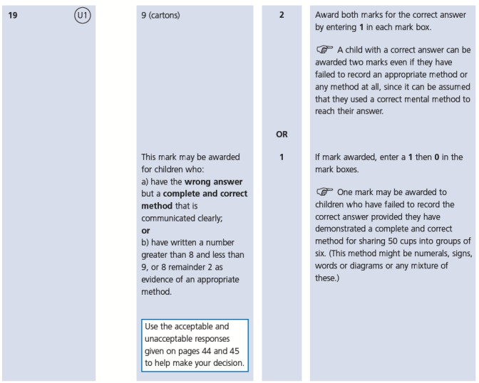
4.
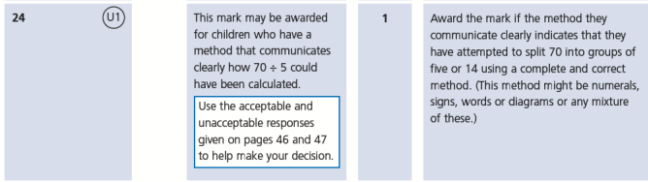
KS1 – 2007 Paper 1
5.
6.
KS1 – 2007 Paper 2
7.
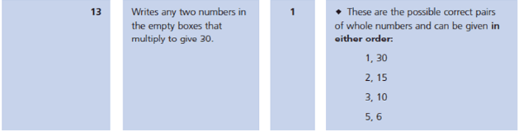
KS1 – 2009 Paper 2
8.
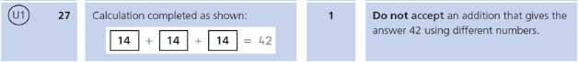
KS1 – 2016 Paper - Reasoning
9.
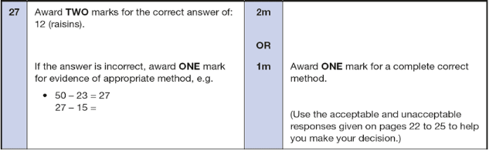
KS1 – 2016 Paper – Reasoning (Second)
10.
KS1 – 2017 Paper – Reasoning
11.
KS1 – 2018 Paper – Reasoning
12.
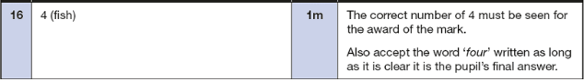
KS1 – 2019 Paper – Reasoning
13.
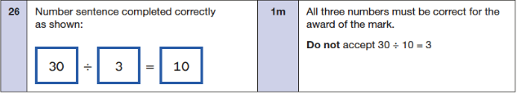
KS1 – 2022 Paper – Reasoning
14.
15.

